Cosmics in Dalseter with GB Nordic, March, 2018

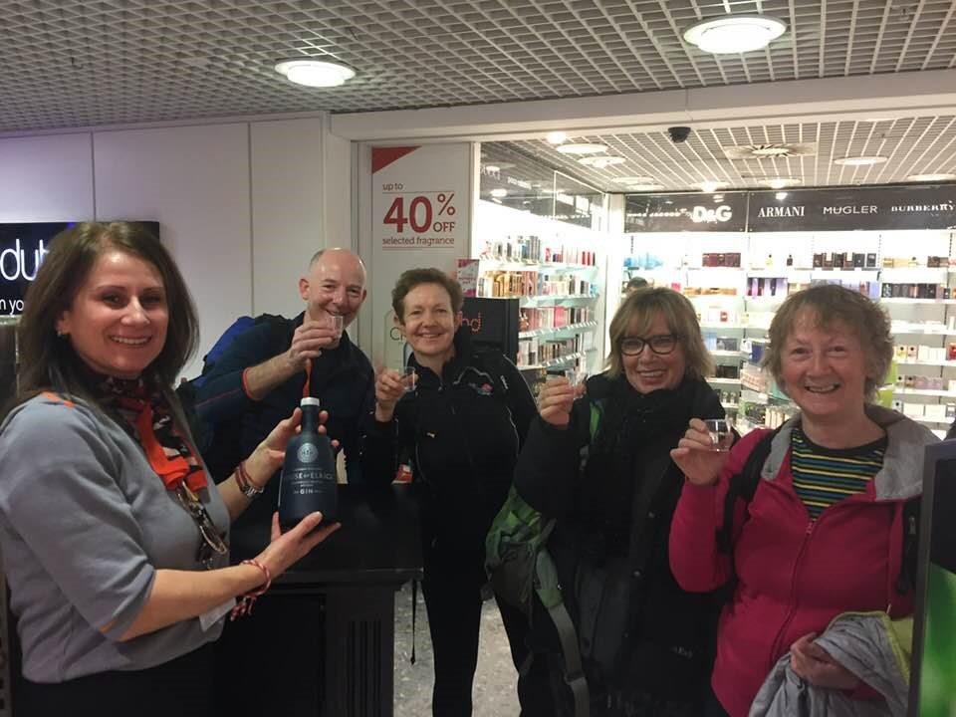

9 0'clock in the morning. Off to Norway.

The train glided through the snowy landscape on the way to Vinstra and from there we took a minibus through snow and ice covered roads to the Dalseter Hoyfjellhotell. Always ready for some cross-training a group of Cosmics went to Norway in March 2018 for a week of Cross-country skiing.

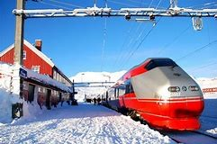

This was my third time at Dalseter, the first was an overnight stay in March 2016 with a smaller group of Cosmics at the start of a week long tour called the Peer Gynt Loipe. The second time was the following year when I spent five days there with the GB Nordic team. GB Nordic is a group of qualified instructors who base themselves at Dalseter Hotel for about a month each year and offer various levels and types of skiing.

The set-up seemed ideal for the various levels of prior experience to be found in the Cosmics. And so it proved, with two of our number joining a beginners/returners track skiing group, two going with the full on off-piste group, and the rest of us doing a mix of introductory off-piste and harder track skiing. The hotel is superbly suited to skiing of all types; it even has its own tow and downhill slope on which expert telemarkers can strut their stuff. It is surrounded by over 100k of well-cut tracks and limitless off-piste opportunities.

Steve and Colin were the main off-pisters and they made the most of the brilliant weather that lasted all week by going out with two of the off-piste instructors – Pete and Tom - up the big mountains that surround the hotel.

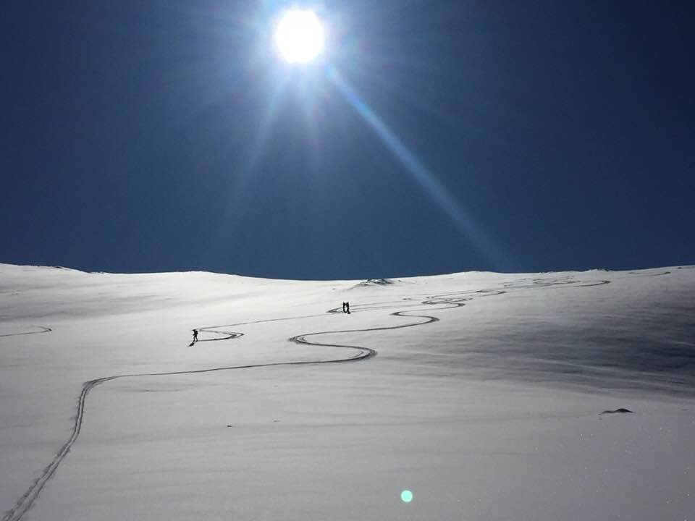

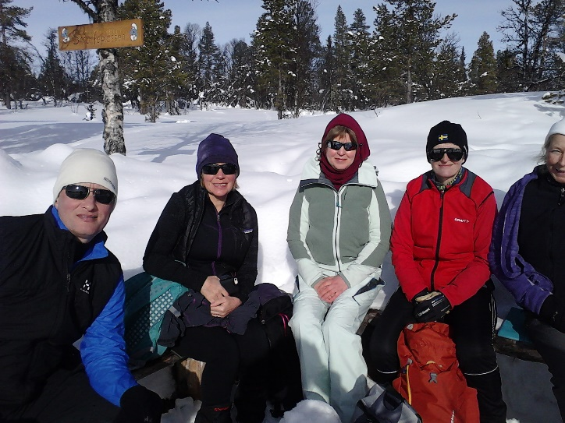
Richard (beginner) and Margaret (returner) were well pleased with both the quality and price of their instruction available from Pam and they went out with her small group most days, making it as far as one of the remote warmed huts out on the fjell that the hotel provides. (the piste machine man goes up there most days and puts the fire on).

Sue and Pauline teamed up with a couple from Boat of Garten and had some brilliant days out on tours around the area.

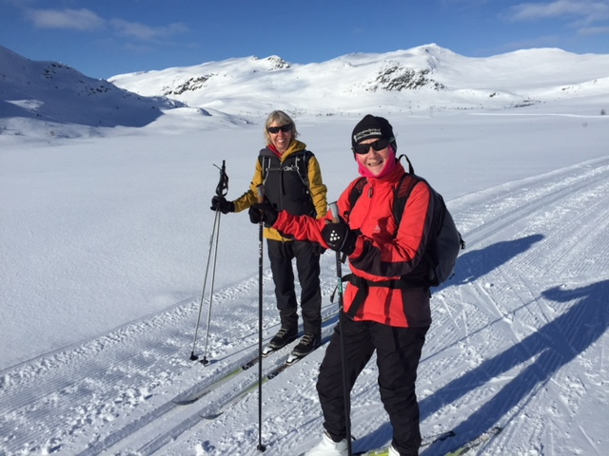
I played the field and did both track skiing with Dagmar the instructor and off-piste with John Mordue or Tom. I finally managed to summit Ruten, the biggest local mountain, with Tom on back-country skis, apart for the last couple of hundred metres which involved taking off the skis and picking a way to the stony summit. The day was a triumph for Duct Tape (or is it Duck Tape?) as my ski baskets disintegrated - not what you want to happen on the top of a 1500m mountain in Norway. Another day with John involved skiing up to a col below Ruten and then
skiing down the lovely powder snow bowls back to the tree-line and then tree-bashing through to a lovely glide down the piste back to the hotel for afternoon tea.

A “must do” track-ski challenge is Dalseter to Fefor Hotel and back.(40k) The Fefor hotel is where Captain Scott of Antarctica fame tested the snow tractor and tried to learn to ski. It serves wonderful waffles and coffee – a great incentive. I was so incentivised I did it twice.!
Myself, Pauline, Colin, Sue and Elaine all completed the trip, Elaine doing very well considering it was her first time on skinny skis.
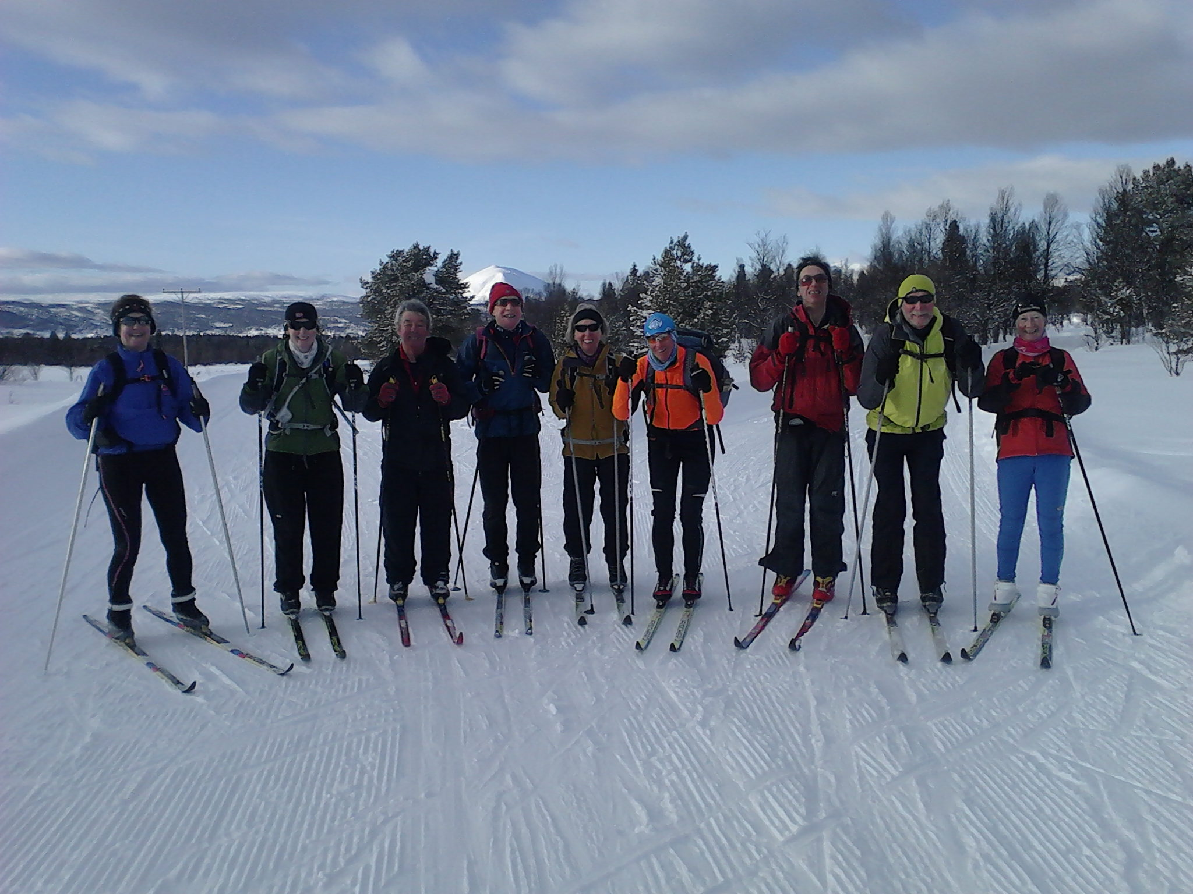

Dalseter to Fefor and return 1st group

Dalseter is nice hotel run by xc enthusiasts with all the facilities including ski-hire and ski prep room. Food is excellent and plentiful and you can make your lunch pack from your breakfast in the normal Norwegian way. Rooms are not too expensive. (Full board with GB Nordic is £70+ per day at that time of year). Everyone meets up with the GB Nordic team every evening to discuss the next day’s options and there was even a ceilidh. These weeks are suitable for skiers with some experience on snow. I would recommend that you try them out. Book GB Nordic through the hotel: http://www.dalseter.no/norsk-web/hotellet.html

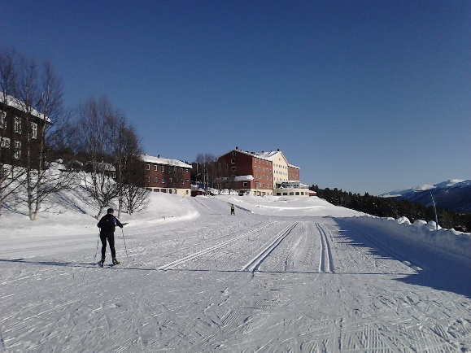

Rod Campbell, April 2018

